Photo from Carline Attwood via unsplash.com
HEALTHY HACKS FOR LOW COST MEALS
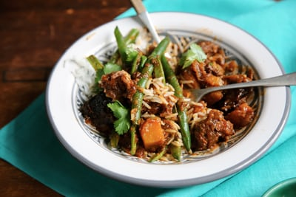
Packaged noodles, boxed mac and cheese dinners and “helper” meals are familiar low cost food options that taste good and are easy to prepare. Give these meals a healthy upgrade by lowering the sodium, boosting the protein and adding in veggies.

Give Ramen a Healthy Makeover
Lower the sodium: Lose the seasoning packet. Instead, try adding garlic powder, pepper and a pinch of salt. A bit of dried herbs may also be added.
Boost the protein: Stir in a few bits of left over chicken or pork chop after cooking (reheat for a few seconds if needed). Chopped scrambled egg is also a great way to add protein.
Add veggies:
Blocks of dried noodles provide a LOT of refined (white) carbohydrate but lack vegetables. Chop leftover veggies such as green beans, carrots or cabbage and add to the raman noodles after cooking. Drained, canned vegetables also work well. For a tasty crunch, add finely chopped fresh veggies such as onion, celery and peppers to the raman noodles after cooking.

Instant Mac and Cheese Upgrades

Lower the sodium: Replace part of the dried cheese mix with 2 to 3 tablespoons of nutritional yeast for a wonderful “cheesy” flavor that is packed with vitamins and minerals.

Boost the protein: Stir in a bit of freshly grated cheese (cheddar, Colby jack, etc.) and an egg while cooking.

Add Veggies: Stir in a small can of low sodium chopped tomatoes (save the tomato juice to add to a soup). A garnish of fresh parsley not only looks pretty, but also tastes great and is packed with nutrients.

A Helping Hand for “Helper” Meals

Lower the sodium: Add only half of the seasoning packet. Add red pepper flakes and celery flakes to make up the difference.

Boost the protein: Sprinkle with grated cheese or nutritional yeast before placing in the oven to bake. If using stovetop method, simply stir in the grated cheese or the nutritional yeast while cooking.

Add Veggies: Cut up fresh or frozen broccoli and add to the helper meal before placing in oven. If using stovetop method add the broccoli while cooking.

Written by Jenny Favret, MS, RD, LDN
Nutritionist, Duke Pediatrics Healthy Lifestyles Program
Jenny.favret@duke.edu

